

January 4, 2018

**Local Logistics Company Supplies Deicing Salt to   
the New England Area- Drone Video**

Brian Kelly at 20eight2 came through for us during the 5 coldest days of 2017. He produced a terrific drone video for us while one of our owned vessels was in the Newport area discharging road salt from Egypt. Click the white arrow for the terrific video he produced for us once his fingers and toes thawed out. Thanks Brian!

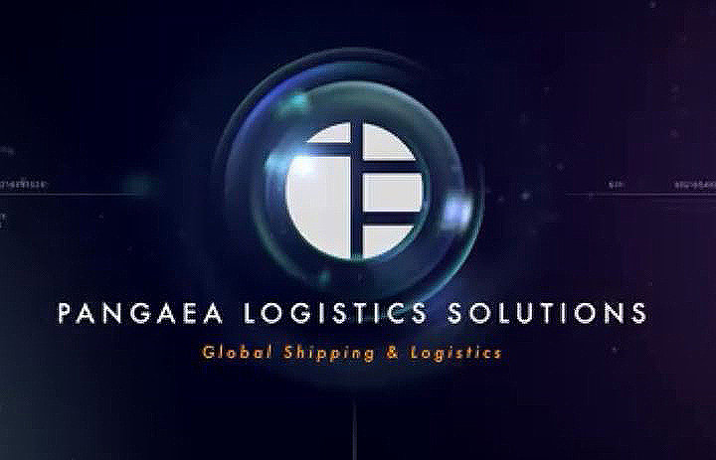

[](file:///O:\Branding\Rebranding\Website\WordPress\Video%20files\Bulk%20Newport%20HD%20Final%203.mp4)